**Chapter 3-6 Notes**

Chapter 3- Clutter is the Enemy-

We experience cognitive load is anytime we take in information

As designers of information we need to be smart about how we use our audiences brain power.

“the larger the share of a graphics ink devoted to data, the better,( other relevant matters being equal)” Edward Tufte

Maximizing the signal to-noise ratio.

What matter most when it comes to our visual communication is the perceived cognitive load on the part of our audience: How hard the believe they are going to have to work to get the information our of you communication.

Clutter-Excessive or extraneous cognitive load.

Clutter makes our visuals appear more complicated than necessary

Gestalt Principles of Visual Perception:

Proximity-We ten to think of objects that are physically close together as belonging to part of a group.

Similarity-Objects that are of similar color, shape, size, or orientation are perceived as related or belonging to a part of a group.

Enclosure- We think of objects that are physically enclosed together as belonging to part of a group.

Closure- concept says that people like things to be simple and to fit in the constructs that are already in our heads.

Continuity- When looking at objects, our eyes seek the smoothest path naturally create continuity in what we see even where it may not explicitly exist.

Connection- We tend to think of objects that are physically connected as part of a group. The connective property typically has a stronger associative value than similar color size, or shape.

Looking at Lack of visual order

Alignment is important- turn on the rulers and gridlines that are built into most programs

Look at visual cues as your audience will typically start at the top left of the page or screen and move their eyes in a “z” shape.

Diagonal components: diagonal elements such as lines and text should be avoided.

White is important as it is a visual communication likened to a pause in public speaking.

Non-strategic use of contrast- this can be a signal to the audience, helping them understand where to focus their attention.

Decluttering: Step-by-step

Any time you put information in front of your audience, you are creating cognitive load and asking them to user their brain power to process that information.

**Chapter 4 Focus your audience’s attention**

Preattentive attributes such as size, color, and position on page can be used strategically.

They can be leveraged to help direct your audience’s attention to where you want them to focus it. Second they can be used to create a visual hierarchy of elements to lead your audience through the information you want to communicate in the way you want them to process it.

**3 types of memory**

Within the brain, there are three types of memory that are important to understand as we design visual communications: iconic memory, short‐term memory, and long‐term memory.

**Iconic memory** is super fast. It happens without you consciously realizing it and is piqued when we look at the world around us.

**Short‐term memory** has limitations. Specifically, people can keep about four chunks of visual information in their short‐term memory at a given time.

**Long‐term memory** is built up over a lifetime and is vitally important for pattern recognition and general cognitive processing.

One thing to be aware of is that people tend to associate quantitative values with some (but not all) of the preattentive attributes. For example, most people will consider a long line to represent a greater value than a short line. That is one of the reasons bar charts are straightforward for us to read. But we don’t think of color in the same way.

**Preattentive attributes in text**

Without any visual cues, when we’re confronted with a block of text, our only option is to read it. But preattentive attributes employed sparingly can quickly change this.

Beyond drawing our audience’s attention to where we want them to focus it, we can employ preattentive attributes to create visual hierarchy in our communications.

**Size**

Size matters. Relative size denotes relative importance. Keep this in mind when designing your visual communications.

**Color**

When used sparingly, color is one of the most powerful tools you have for drawing your audience’s attention. Resist the urge to use color for the sake of being colorful; instead, leverage color selectively as a strategic tool to highlight the important parts of your visual. The use of color should always be an intentional decision.

**Use color sparingly**

It’s easy to spot a hawk in a sky full of pigeons, but as the variety of birds increases, that hawk becomes harder and harder to locate.

**Design with colorblind** in mind Roughly 8% of men (including my husband and a former boss) and half a percent of women are colorblind. This most frequently manifests itself as difficulty in distinguishing between shades of red and shades of green. In general, you should avoid using shades of red and shades of green together. Sometimes, though, there is useful connotation that comes with using red and green: red to denote the double‐digit loss you want to draw attention to or green to highlight significant growth. You can still leverage this, but make sure to have some additional visual cue to set the important numbers apart so you aren’t inadvertently disenfranchising part of your audience. Consider also using bold, varying saturation or brightness, or adding a simple plus or minus sign in front of the numbers to ensure they stand out.

**Chapter 5 think like a designer**

In the field of design, experts speak of objects having **“affordances.”** These are aspects inherent to the design that make it obvious how the product is to be used. For example, a knob affords turning, a button affords pushing, and a cord affords pulling. These characteristics suggest how the object is to be interacted with or operated.

**Highlight** the important stuff We’ve previously demonstrated the use of preattentive attributes to draw our audience’s attention to where we want them to focus: in other words, to highlight the important stuff. Let’s continue to explore this strategy. Critical here is to only highlight a fraction of the overall visual, since highlighting effects are diluted as the percentage that are highlighted increases.

* Bold, italics, and underlining: Use for titles, labels, captions, and short word sequences to differentiate elements. Bolding is generally preferred over italics and underlining because it adds minimal noise to the design while clearly highlighting chosen elements. Italics add minimal noise, but also don’t stand out as much and are less legible. Underlining adds noise and compromises legibility, so should be used sparingly (if at all).
* CASE and typeface: Uppercase text in short word sequences is easily scanned, which can work well when applied to titles, labels, and keywords. Avoid using different fonts as a highlighting technique, as it’s difficult to attain a noticeable difference without disrupting aesthetics.
* Color is an effective highlighting technique when used sparingly and generally in concert with other highlighting techniques (for example, bold).
* Inversing elements is effective at attracting attention, but can add considerable noise to a design so should be used sparingly.
* Size is another way to attract attention and signal importance

To identify distractions, think about both clutter and context. Determine whether there are things that might be distracting from your main message or point. All of these are candidates for elimination

* Not all data are equally important. Use your space and audience’s attention wisely by getting rid of noncritical data or components.
* When detail isn’t needed, summarize. You should be familiar with the detail, but that doesn’t mean your audience needs to be. Consider whether summarizing is appropriate.
* Ask yourself: would eliminating this change anything? No? Take it out! Resist the temptation to keep things because they are cute or because you worked hard to create them; if they don’t support the message, they don’t serve the purpose of communication.
* Push necessary, but non‐message‐impacting items to the background. Use your knowledge of preattentive attributes to de‐ emphasize. Light grey works well for this.

Don’t over complicate

* Make it legible: use a consistent, easy‐to‐read font (consider both typeface and size).
* Keep it clean: make your data visualization approachable by leveraging visual affordances.
* Use straightforward language: choose simple language over complex, choose fewer words over more words, define any specialized language with which your audience may not be familiar, and spell out acronyms (at minimum, the first time you use them or in a footnote).
* Remove unnecessary complexity: when making a choice between simple and complicated, favor simple.

Text plays a number of roles in communicating with data: use it to label, introduce, explain, reinforce, highlight, recommend, and tell a story.

Aesthetics

1. Be smart with color. The use of color should always be an intentional decision; use color sparingly and strategically to highlight the important parts of your visual.
2. Pay attention to alignment. Organize elements on the page to create clean vertical and horizontal lines to establish a sense of unity and cohesion.
3. Leverage white space. Preserve margins; don’t stretch your graphics to fill the space, or add things simply because you have extra space.

Acceptance:

There are a few strategies you can leverage for gaining acceptance in the design of your data visualization:

* Articulate the benefits of the new or different approach. Sometimes simply giving people transparency into why things will look different going forward can help them feel more comfortable. Are there new or improved observations you can make by looking at the data in a different way? Or other benefits you can articulate to help convince your audience to be open to the change?
* Show the side‐by‐side. If the new approach is clearly superior to the old, showing them side‐by‐side will demonstrate this. Couple this with the prior approach by showing the before‐and‐after and explaining why you want to shift the way you’re looking at things.
* Provide multiple options and seek input. Rather than prescribing the design, consider creating several options and getting feedback 150 think like a designer  from colleagues or your audience (if appropriate) to determine which design will best meet the given needs.
* Get a vocal member of your audience on board. Identify influential members of your audience and talk to them one‐on‐one in an effort to gain acceptance of your design. Ask for their feedback and incorporate it. If you can get one or a couple of vocal members of your audience bought in, others may follow.

**Chapter 6 dissecting model visuals**

This is one of those cases where there isn’t a single right answer: you should think about the context, the data, and how you want your audience to use the visual and make a deliberate decision in light of those things.

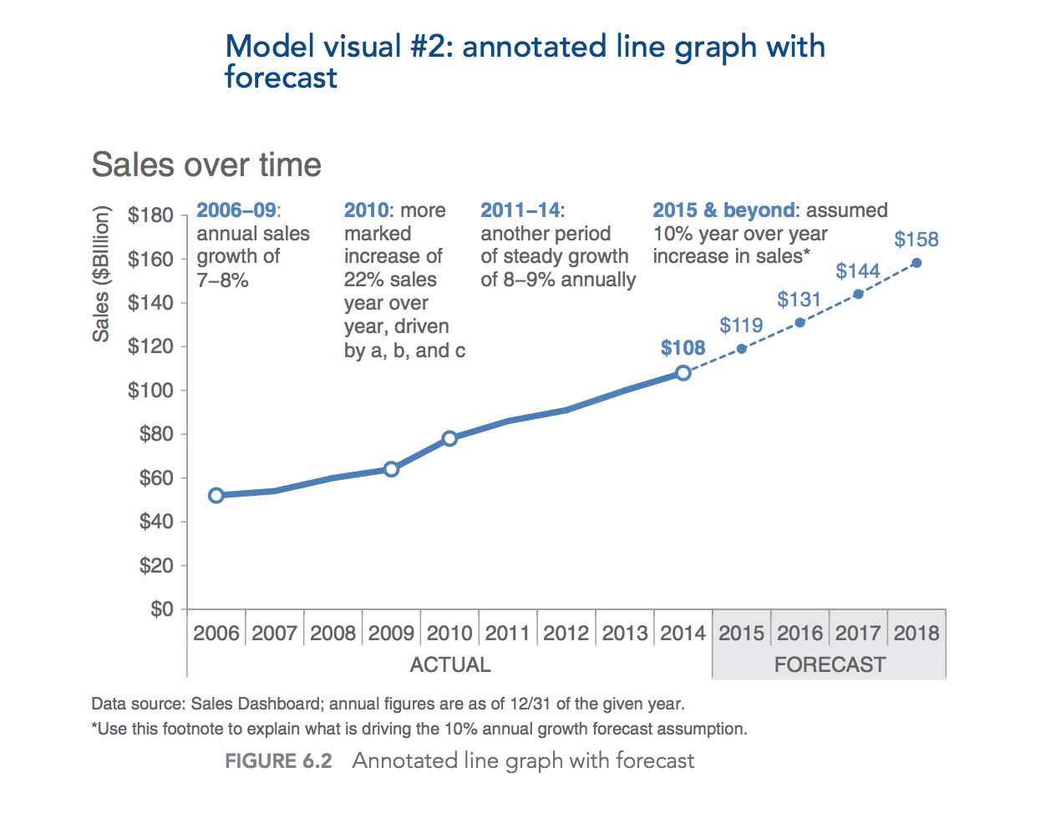

All text in the visual is the same size except where intentional decisions were made to change it. The graph title is larger. The footnote is de‐emphasized via smaller font and a low‐priority placement at the bottom of the visual so that it is there to aid interpretation as needed, but doesn’t draw attention

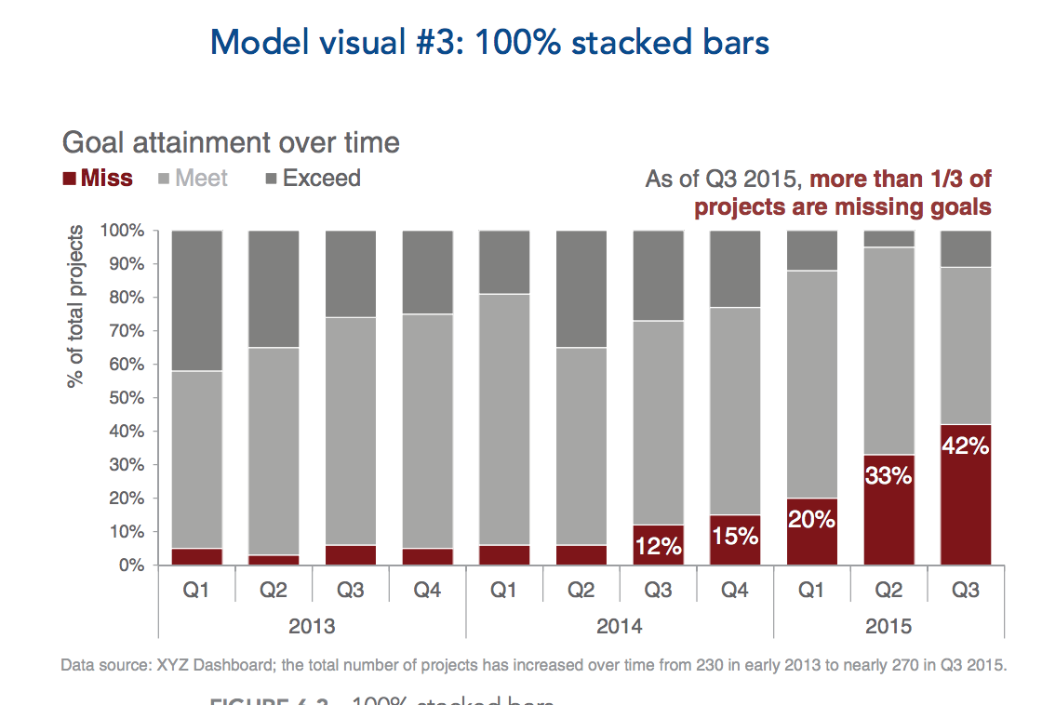

The graph title, legend, and vertical y‐axis title are all aligned in the upper‐left‐most position. This means our audience encounters how to read the graph before they get to the data. On the left‐hand side, the graph title, legend, y‐axis title, and footnote are all aligned, creating a clean line on the left side of the visual. On the right‐hand side, the text at the top is right‐justified and aligned with the final bar of data that contains the data point being described (leveraging the Gestalt principle of proximity). This same text box is aligned vertically with the graph legend

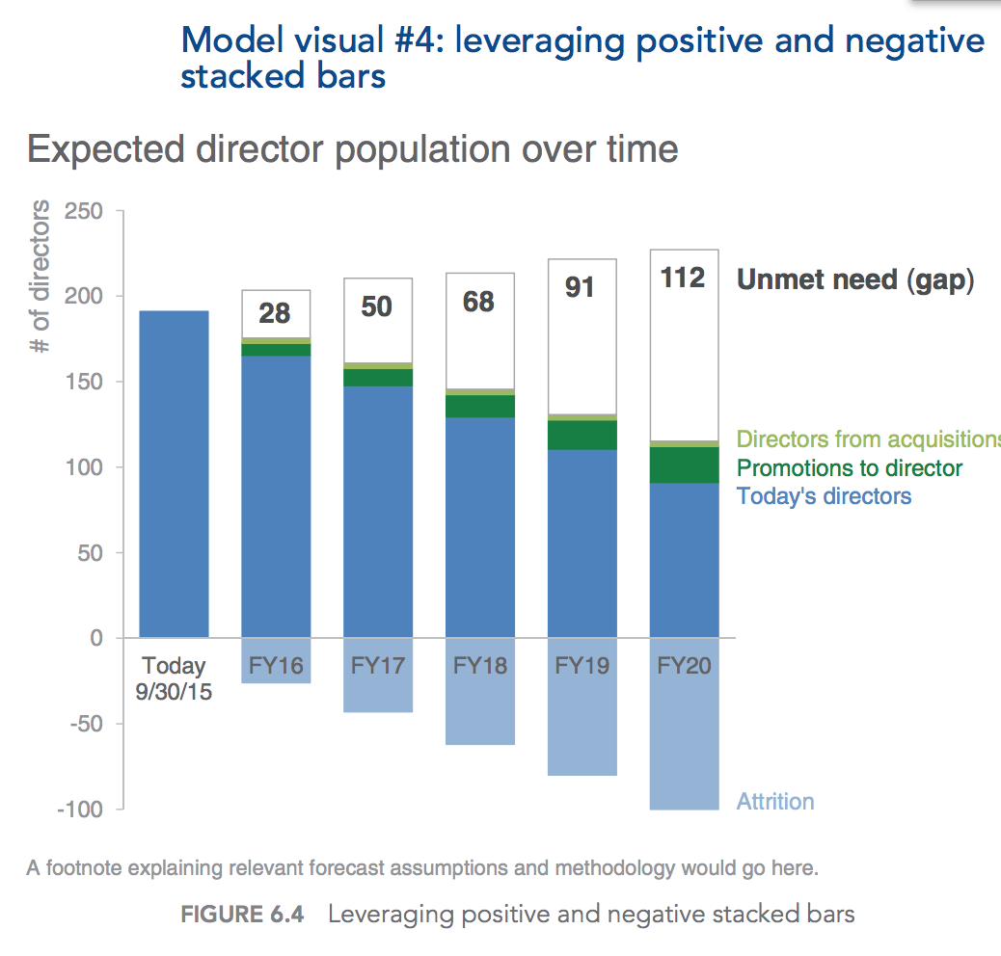

Over time, you see less of the blue falling above the axis and an increasing proportion falling below the axis as more and more directors attrite. The negative direction of the “Attrition” series reinforces that this volume represents a decrease to the director pool. Directors added through acquisitions and promotions are shown in green (which carries positive connotation). The unmet need is depicted by an outline only, to visually show empty space, reinforcing that this represents a gap. The text labels on the right are each written in the same color as the given data series they describe, except “Unmet need (gap),” which is written in the same big, bold, black text as the data labels for this series. The ordering of the various data series within the stacked bars is deliberate. “Today’s directors” is the base, and as such is shown beginning at the horizontal axis.

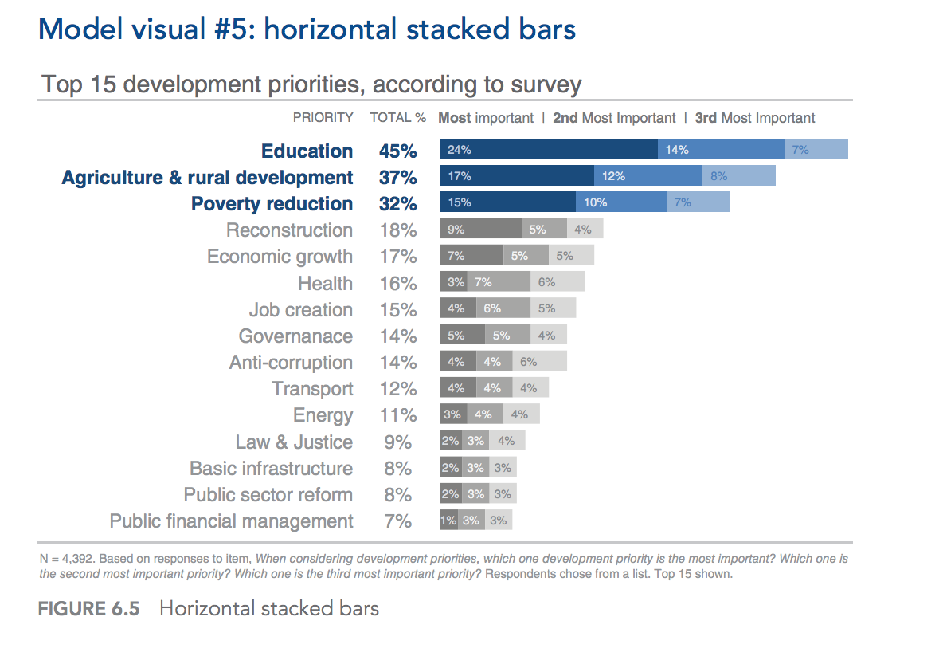

One decision point when graphing data is whether to preserve the axis, label the data points (or some data points) directly, or both. In this case, the numeric data labels within the bars have been preserved, but de‐emphasized with smaller text (oriented to the left, which creates a clean line as you scan down the data labels for the “Most important,” making it feel slightly less cluttered than right‐ or center‐oriented text that would vary in position across each of the bars). The data labels were further de‐emphasized through the color they are written in: a light shade of blue or grey that doesn’t create as stark a contrast as white labels on a colored bar. The x‐axis was eliminated altogether. Here, we implicitly assume that the specific values are important enough to label. Another scenario may call for a different approach. As we noted with a number of the previous examples, words are used well in this visual. Everything is titled and labeled. The titles “Priority” and “Total %” are written all in caps for easy scanning. The legend for the interpretation of the bars appears immediately above the first bar of data with the keywords “Most,” “2nd,” and “3rd” bolded for emphasis. Additional detail is described in the footnote